Question 1
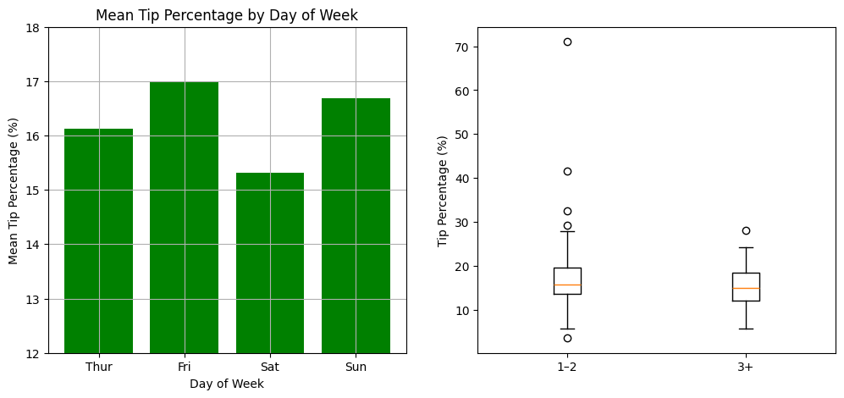
- Recreate this side-by-side visualization using plt.subplots (matplotlib) and loading in the seaborn “tips” dataset. The figsize=(12, 5). You will need to set_ylim(12,18) and use a green color as well as a grid for the graph on the left. The graph on the right is incomplete. You will need to set_xlabel and set_title.
- Use seaborn to load_dataset(“tips”). Create a new column [‘tip_pct’]. You will need to use .groupby() and .mean() for the graph on the left. For the graph on the right, figure out which column is being portrayed on the x-axis. Then, create a new ‘group’ column in your pandas dataframe using the apply function: df["group"] = df["name_of_column"].apply(lambda x: "1–2" if x <= 2 else "3+")
- Create 2 filtered Pandas series with only “1-2” and then only “3+”. Have only ["tip_pct"] as your column and filter based on df["group"]. Name them group1 and group2. Use these as your data for your .boxplot([group1, group2], tick_labels = ["1–2", "3+"])

Question 2
On the ICON home page, navigate to the Final Coding Portion assignment. Download and use pd.read_csv for Life_Expectancy.csv. This is the life expectancy in years for counties across the U.S.
- Calculate mean and standard deviation for life_expectancy column.
- Create a new column ‘category’. If the county’s life expectancy > mean + stdev, ‘category’ is “Long”, else if life expectancy < mean – stdev then ‘category’ is “Short”. Else “Average”. Achieve this with a user-defined function def life_exp(value). Use apply again to apply that function to the entire life_expectancy column: df["category"] = df["life_expectancy"].apply(life_exp)
- Filter out “Average” counties in this ‘category’ column so you’re left with 415 Short and 403 Long.
- Use label_binarize from sklearn to turn df.category into 1 – Long, 0 – Short
- Drop Year, County_Name, State_Name, and the original life_expectancy column.
- Perform a grid search (GridSearchCV) with your six X features: X = df[['diversity','smoking','obesity','house_income','unemployment_rate','pct_edu_or_health']] and target (y) variable – df[‘category’] to see which machine learning algorithm and hyperparameters has the highest auc_roc (area under the ROC Curve)
  - KNN Classifier – 3 or 5 'n_neighbors' and euclidean or manhattan 'metric' (distance)
  - Decision Tree - 'max_depth': [5, None], 'min_samples_split': [5, 10]
    - Make sure estimator=DecisionTreeClassifier(random_state=0),
  - Make sure scoring=’roc_auc’, cv = 5 for 5 cross validation folds
  - Fit the Grid Search model and display cv_results_ as pandas dataframes for both models.
  - In a final markdown cell, write which 1) Model and 2) Parameters had the highest mean_test_score (roc_auc).

